Monday | Tuesday | Wednesday | Thursday | Friday
3 Frozen Meal Pickup  9:30 am – 10:30 am Door #4 | 4 No Meals Served | 5 | 6 | 7
TRAY MEAL SERVED  Pork Ribette with BBQ Sauce on a Bun  Cheesy Diced Potatoes  Brussels Sprouts  Applesauce (732) | Senior Center Event | Cheese Ravioli with Tomato Meat Sauce &  Mozzarella Cheese  Peas Grape Juice  Chef Salad with Dressing  Italian Bread  Chocolate Ice Cream (943) | Roast Turkey with Stuffing, Gravy & Cranberry Sauce  Sweet Potatoes  Green Bean Casserole  Pineapple Tidbits  Chocolate Milk (670) | Salisbury Steak with Gravy  Scalloped Potatoes  Mixed Vegetables  Wheat Bread  Mandarin Oranges (708)
10 Frozen Meal Pickup  9:30 am – 10:30 am Door #4 | 11 | 12 | 13 Father’s Day Lunch | 14 Flag Day Meal
TRAY MEAL SERVED  Turkey Tetrazzini  Carrots Apple Juice  Wheat Dinner Roll  Lorna Doones (676) | Italian Sausage with Peppers, Onion, Tomato Sauce & Mozzarella Cheese on a Bun  Seasoned Potatoes  Spinach  Brownie (673) | Beef Stroganoff over Pasta  Green Beans  Cauliflower  Fresh Banana  Chocolate Milk  (627) | Breaded Pork Chop with Gravy  Ranch Mashed Potatoes  Peas with Pearl Onions  Chef Salad with Dressing  Whole Wheat Dinner Roll  Boston Cream Pie (895) | Grilled Chicken Breast with BBQ Sauce  Potatoes O’Brien  Corn-on-the-Cob  Dinner Roll  Chef Salad with Dressing  Orange Creamsicle (712)
17 Frozen Meal Pickup  9:30 am – 10:30 am Door #4 | 18 Juneteenth Lunch | 19 No Meals Served | 20 Welcome Summer! | 21
TRAY MEAL SERVED  Turkey a la King  Harvard Beets  California Vegetable Blend  Wheat Dinner Roll  Diced Pears (563) | Breaded Chicken Drumsticks  Sweet Potatoes  Seasoned Mixed Greens  Corn Muffin  Chef Salad with Dressing  Banana Cream Pie (1135) | Senior Center Closed  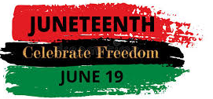 | Grilled Chicken, Mandarin Orange & Sunflower Salad  Whole Wheat Dinner Roll  Lemon Meringue Pie  (823) | Stuffed Pepper with Tomato Meat Sauce  Garlic Mashed Potatoes  Italian Bean Medley  Wheat Bread  Fruit Cocktail  Chocolate Milk (678)
24 Frozen Meal Pickup  9:30 am – 10:30 am Door #4 | 25 | 26 Entrée Salad | 27 | 28
TRAY MEAL SERVED  Beef Pepper Steak Casserole over Rice  Green Beans  Grape Juice  Fudge Round Cookie  (735) | Lasagna Roll with Tomato Meat Sauce & Mozzarella  Cauliflower  Chef Salad with Dressing  Dinner Roll  Sugar Cookies  (828) | Garden Chicken Patty Salad with Cheddar Cheese, Croutons & Ranch Dressing  Dinner Roll  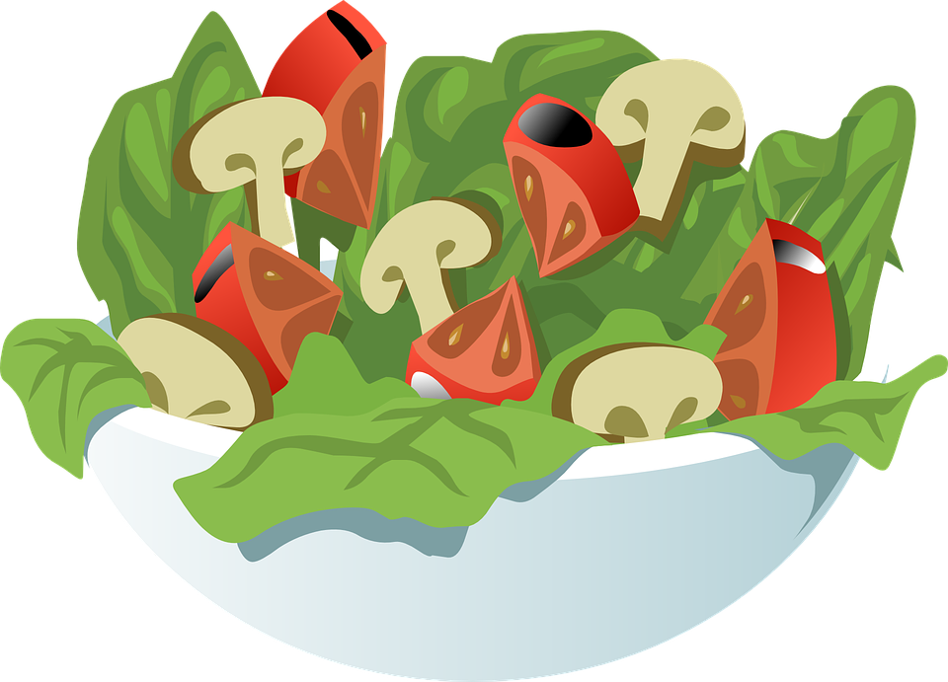  Pineapple Tidbits  Chocolate Milk  (917) | Chicken Breast with Lemon Herb Sauce  Broccoli Cheese Rice Casserole Carrots  Wheat Dinner Roll  Chef Salad with Dressing  Mandarin Oranges (710) | Turkey Burger with BBQ Sauce on a Bun  Cheesy Diced Potatoes  California Mixed Vegetables  Strawberry Gelatin  (682)
