Monday | Tuesday | Wednesday | Thursday | Friday
3 Frozen Meal Pickup  9:30 am – 10:30 am Door #4 | 4 | 5 | 6 | 7 Veterans Day Meal
REGULAR MEAL SERVED  Beef Macaroni Casserole with Cheddar Cheese  Green Beans  Apple Juice Italian Bread  Butterscotch Pudding (839) | Hot Dog with Baked Beans & Ketchup on a Bun  Macaroni & Cheese    Carrots  Tropical Fruit (746) |   Chicken Breast with Red Pepper Cream Sauce    Mashed Potatoes  Broccoli Florets  Wheat Dinner Roll  Lorna Doones (634) | Beef Bourguignon    Harvard Beets  Fresh Peas    Multigrain Bread  Fresh Orange  Chocolate Milk (647) | Breaded Boneless Pork Chop with Gravy Scalloped Potatoes  California Blend Vegetables  Chef Salad with Dressing  Wheat Dinner Roll  Lemon Meringue Pie (945)
10 Frozen Meal Pickup  9:30 am – 10:30 am Door #4 | 11 No Meals Served | 12 Soup & Salad | 13 | 14
No Meals Served    Travel Club Event |   Senior Center Closed | 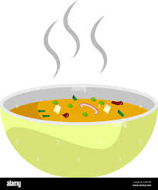  Beef Barley Soup  Green Beans  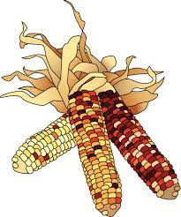  Orange Pineapple Juice  Chef Salad with Dressing  Warm Biscuit  Vanilla Pudding  (712) | Stuffed Shells with Tomato Meat Sauce & Mozzarella      Cauliflower  Peas  Italian Bread  Diced Pears  Chocolate Milk  (825) | Roasted Turkey with Stuffing, Gravy & Cranberry Sauce  Garlic Mashed Potatoes  Corn    Chocolate Brownie  (706)
17 Frozen Meal Pickup  9:30 am – 10:30 am Door #4 | 18 |   19 | 20 | 21 Taco Day!
REGULAR MEAL SERVED    Sloppy Joe on a Bun  Tater Tots  Mixed Vegetables  Mandarin Oranges (714) | Hearty Pork Stew  Mashed Potatoes    Broccoli Florets  Warm Biscuit  Fresh Banana  Chocolate Milk (709) | Lasagna Roll with Tomato Meat Sauce & Mozzarella  Cauliflower  Carrots  Italian Bread  Oatmeal Round Cookie (752) | Chicken Breast with Lemon Herb Gravy    Vegetable Rice Pilaf  Green Beans  Chef Salad with Dressing  Dinner Roll  Pineapple Tidbits (664) | 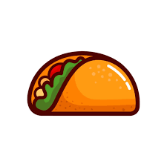  Ground Beef Taco with Shredded Cheddar on a Flour Tortilla    Spanish Rice  Fiesta Corn  Tropical Fruit (727)
24 Frozen Meal Pickup  9:30 am – 10:30 am Door #4 | 25 Thanksgiving Meal | 26 | 27 No Meals Served | 28 No Meals Served
TRAY MEAL SERVED  Macaroni & Cheese  Peas with Red Pepper  California Blend Vegetables  Wheat Bread  Rice Krispie Treat (895) | Roasted Turkey with Stuffing, Gravy & Cranberry Sauce  Sweet Potatoes  Green Bean Casserole  Dinner Roll  Pumpkin Pie with Whipped Topping (964) | Pork Ribette with BBQ Sauce on a Bun  Duchess Potatoes  Broccoli Florets  Fresh Orange  Chocolate Milk (798) |    | Senior Center Closed  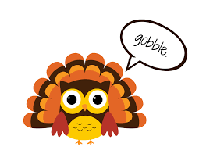
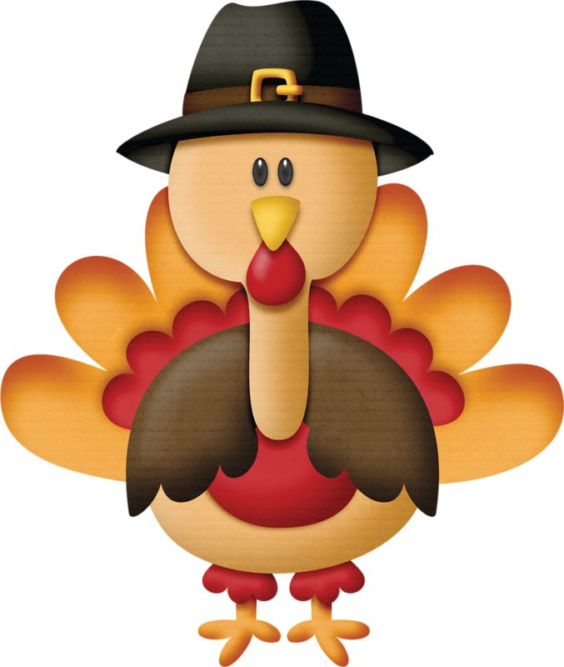







*If you have a food allergy, please notify us.

