Monday | Tuesday | Wednesday | Thursday | Friday
1 Frozen Meal Pickup  9:30 am – 10:30 am Door #4  TRAY MEAL SERVED  Chicken & Sausage Paella  Rice with Black Beans  Corn with Red Pepper  Cauliflower  Chocolate Pudding (601) | 2  Beef Macaroni Casserole with Mozzarella    Peas & Carrots    Grape Juice  Multigrain Bread  Lemon Ice (768) | 3  Breaded Chicken Cutlet with Buffalo-style Sauce on a Bun  Mashed Potatoes  Carrots    Tropical Fruit (839) | 4 Entrée Salad  Tuna Salad on a Bed of Fresh Salad Greens  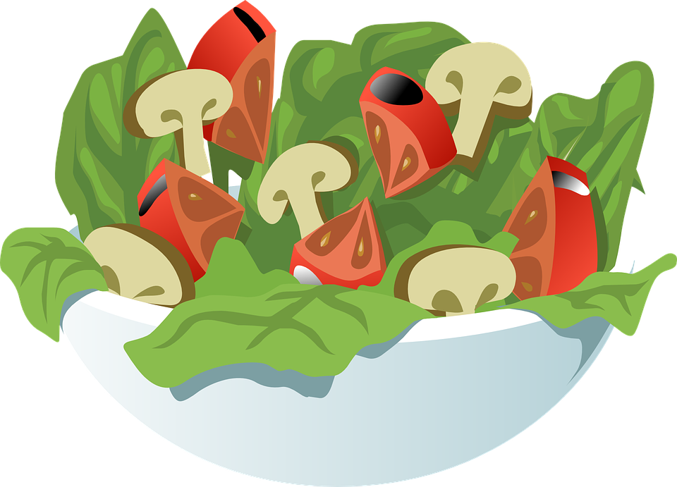  Club Crackers  Fudge Round Cookie (664) | 5  Lower Sodium Baked Ham with Maple Glaze  Mashed Sweet Potatoes  California Blend Vegetables    Rye Bread  Pineapple Tidbits  Chocolate Milk (622)
8 Frozen Meal Pickup  9:30 am – 10:30 am Door #4 | 9 Soup & Salad |   10 |   11 | 12
TRAY MEAL SERVED    Hearty Turkey Stew  Garlic Mashed Potatoes  Green Beans  Dinner Roll  Oatmeal Cookies (713) | Broccoli Cheddar Soup with a Warm Biscuit  Carrots    Chef Salad with Dressing    Strawberry Gelatin  (731) | Tortellini with Tomato Meat Sauce & Mozzarella  Mixed Vegetables  Chef Salad with Dressing  Grape Juice Italian Bread  Fresh Banana (822) | Roast Pork Loin with Gravy    Mashed Potatoes  Brussels Sprouts  Dinner Roll  Applesauce  Chocolate Milk (634) |   Beer Battered Fish with Tartar Sauce  Broccoli Cheese Rice Casserole  Zucchini & Tomatoes  Wheat Dinner Roll  Pineapple Tidbits (677)
15 Frozen Meal Pickup  9:30 am – 10:30 am Door 4 |   16 | 17 Christmas Lunch | 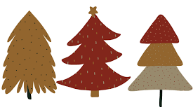  18 | 19 Welcome Winter
No Meals Served  Senior Center Event   | Italian Sausage with Peppers, Onions & Tomato Sauce on a Bun  Seasoned Potatoes  Green Beans  Pineapple Tidbits (587) |     Broccoli-stuffed Chicken with Creamy Herb Gravy  Vegetable Rice Pilaf  Peas with Red Pepper  Chef Salad with Dressing  Dinner Roll  Cheesecake with Chocolate Sauce (1044) | Beef Bourguignon  Harvard Beets  California Blend Vegetables  Dinner Roll  Fresh Orange  Chocolate Milk (602) | Roasted Turkey with Stuffing, Gravy & Cranberry Sauce  Mashed Potatoes  Mixed Vegetables      Apple Pie with Whipped Topping (894)
22 Frozen Meal Pickup  9:30 am – 10:30 am Door #4 | 23 | 24 No Meals Served | 25 No Meals Served |   26
TRAY MEAL SERVED  Cheese Omelet with Creole Sauce Cheesy  Diced Potatoes  Green Beans Muffin Mandarin Oranges (662) | Chili con Carne with Cheddar Carrots  Chef Salad with Dressing  Apple Juice  Corn Muffin Fresh Banana(912) | Senior Center  Closed |   Senior Center Closed | Breaded Chicken Cutlet with Buffalo-style Sauce on a Bun  Tater Tots Mixed Vegetables  Pineapple Tidbits  Chocolate Milk (813)
29 Frozen Meal Pickup  9:30 am – 10:30 am Door #4 | 30 Entrée Salad | 31 New Year’s Meal | 1 No Meals Served |   2
TRAY MEAL SERVED  Beef Stroganoff over Pasta  Corn with Red Peppers  Seasoned Spinach  Tropical Fruit (591) | Chicken Caesar Salad  with Caesar Dressing  Wheat Dinner Roll  Mandarin Oranges (751) |   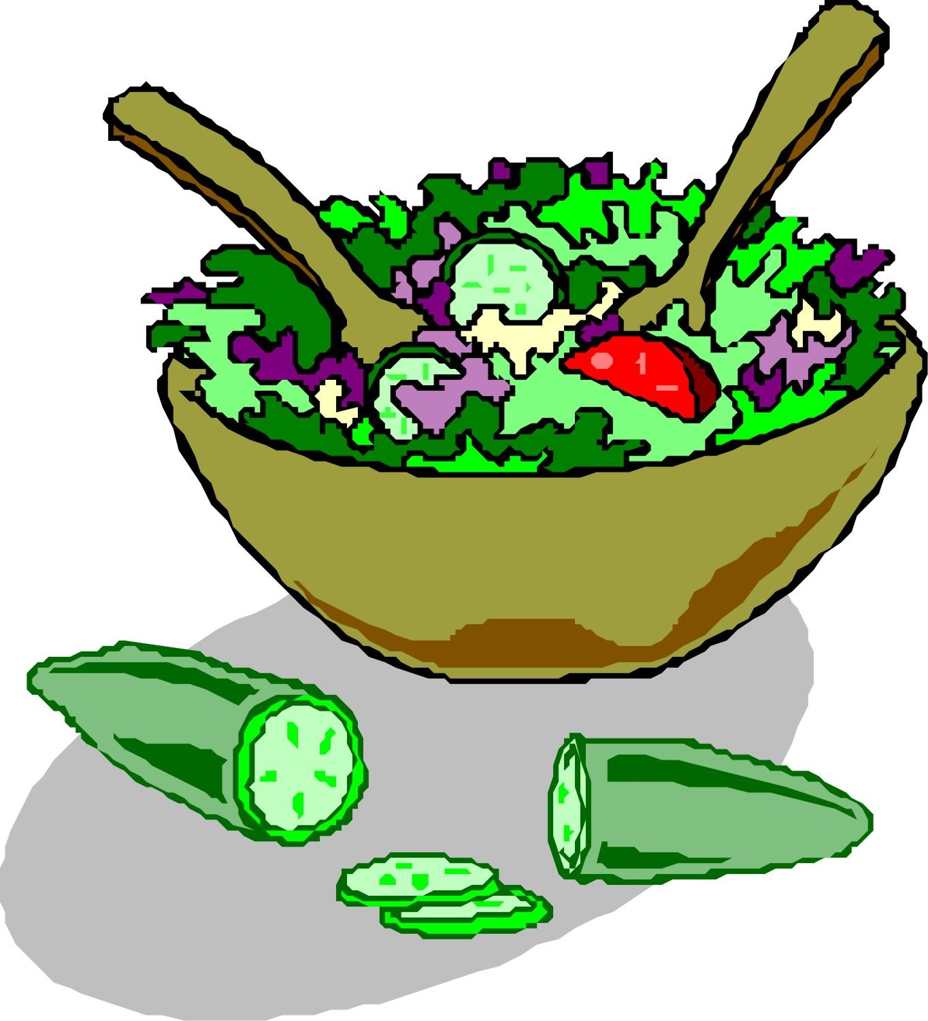  Pork Loin with Stuffing & Cranberry Chutney  Scalloped Potatoes  Brussels Sprouts    Chef Salad with Dressing  Chocolate Cream Pie (1095) |     Senior Center Closed | Lasagna Roll with Tomato Meat Sauce & Mozzarella  Cauliflower Green Peas  Dinner Roll  Chocolate Brownie (755)








*If you have a food allergy, please notify us.

