Monday | Tuesday | Wednesday | Thursday | Friday
5 Frozen Meal Pickup  9:30 am – 10:30 am Door #4 | 6 Entrée Salad | 7 | 8 | 9
TRAY MEAL SERVED  Hearty Beef Stew  Mashed Potatoes  Brussels Sprouts  Warm Biscuit  Vanilla Pudding (703) | Breaded Chicken Cutlet with Buffalo Sauce on a Bun  Tater Tots    Seasoned Broccoli  Fresh Banana  Chocolate Milk  (824) | Polish Sausage with Sauerkraut & Mustard on a Bun    Ranch Mashed Potatoes  Carrots  Fudge Round Cookie  (847) | Roasted Turkey with Stuffing, Gravy & Cranberry Sauce  Mashed Butternut Squash  Corn  Chef Salad with Dressing  Mandarin Oranges (660) | Cheese Omelet with Creole Sauce  Cheesy Diced Potatoes    Green Beans  Wheat Bread  Tropical Fruit  (628)
12 Frozen Meal Pickup  9:30 am – 10:30 am Door #4 | 13 | 14 | 15 | 16 Martin Luther King Meal
TRAY MEAL SERVED  Lasagna Roll with Tomato Meat Sauce & Mozzarella  Broccoli Florets  Grape Juice  Italian Bread  Sugar Cookies (796) | Swedish Meatballs over Pasta  Harvard Beets  Peas  Chef Salad with Dressing  Pineapple Tidbits    (742) | Chicken Breast with Gravy  Sweet Potatoes  Lima Bean Bake  Dinner Roll    Fresh Orange  Chocolate Milk (656) | Hearty Pork Stew  Mashed Potatoes  Carrots  Dinner Roll  Strawberry Gelatin    (603) | 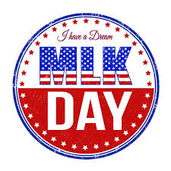  Breaded Chicken  Drumsticks  Red Beans & Rice  Seasoned Greens  Corn Muffin  Banana Cream Pie  (1118)
19 No Meals Served | 20 Frozen Meal Pickup  9:30 am – 10:30 am Door #4 | 21 | 22 Entrée Salad | 23
Senior Center Closed  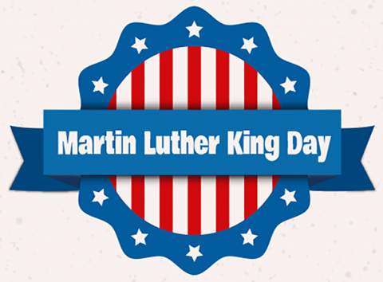 | TRAY MEAL SERVED    Beef Pepper Steak Casserole over Rice  Broccoli Florets  Carrots  Diced Pears (587) | Roast Pork with Warm Apples  Sweet Potatoes  Green Beans  Wheat Bread  Butterscotch Pudding  (644) | Garden Chicken Salad with Cheddar, Croutons & Ranch Multigrain Bread  Fresh Banana    Chocolate Milk  (966) | Stuffed Shells with Tomato Meat Sauce & Mozzarella  Cauliflower  Fruit Punch  Chef Salad with Dressing  Wheat Dinner Roll  Lorna Doones (969)
26 Frozen Meal Pickup  9:30 am – 10:30 am Door #4 | 27 Entrée Salad | 28 | 29 | 30
TRAY MEAL SERVED  Turkey a la King  Mashed Potatoes  Carrots  Warm Biscuit  Chocolate Pudding (685) |   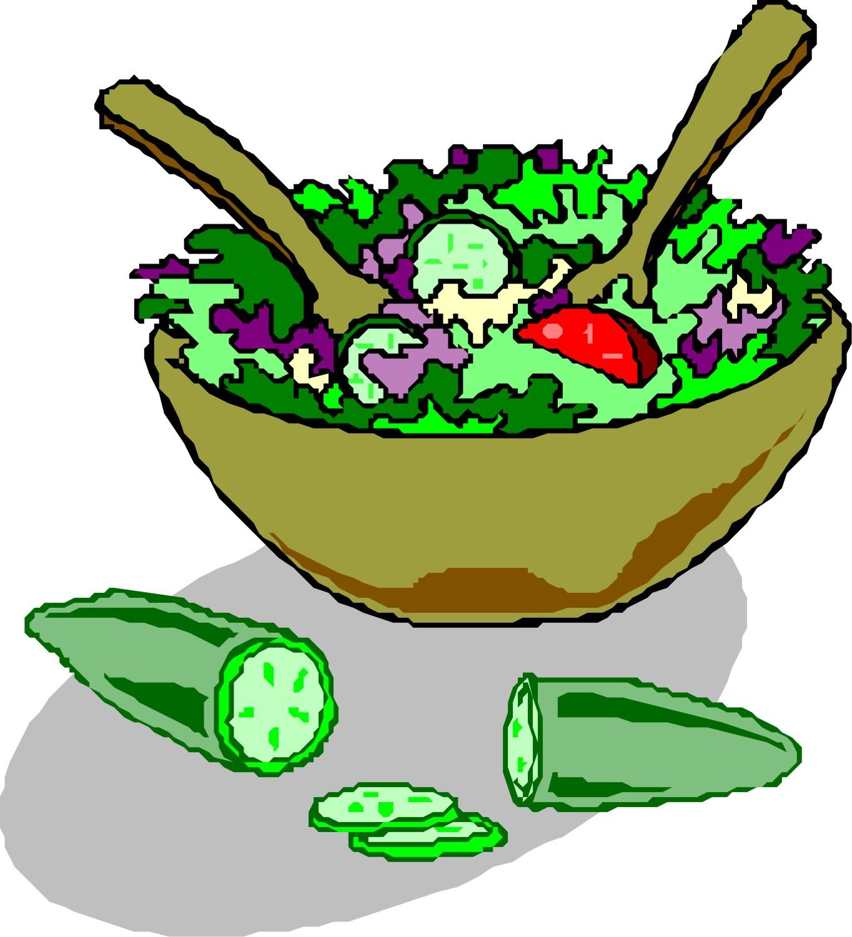  Beef Taco Salad with Tortilla Strips, Cheddar Cheese & Taco Sauce  Pineapple Tidbits  (600) | Italian Sausage with Rigatoni, Tomato Sauce & Mozzarella  California Blend Vegetables  Orange Juice  Chef Salad with Dressing  Dinner Roll  Fresh Banana (790) | Chicken Breast with  Marsala Sauce  Rosemary-seasoned Potatoes  Broccoli Florets  Dinner Roll  Sugar Cookies  (621) | Baked Ham with Pineapple Sauce      Scalloped Potatoes  Brussels Sprouts  Wheat Roll  Mandarin Oranges  Chocolate Milk (588)





*If you have a food allergy, please notify us.

