Monday | Tuesday | Wednesday | Thursday | Friday
2 Frozen Meal Pickup  9:30 am – 10:30 am Door #4 | 3 | 4 | 5 Entrée Salad | 6 Soup & Salad
TRAY MEAL  Breaded Chicken Cutlet with Herb Gravy  Scalloped Potatoes  Broccoli Florets Wheat Bread Fudge Round (820) | Hearty Beef Stew  Mashed Potatoes  Green Peas Dinner Roll  Chocolate Pudding (747) | Lower Sodium Baked Ham with Maple Glaze  Sweet Potatoes  Lima Bean Bake Rye Bread Pineapple Tidbits (619) | Chicken Caesar Salad with Caesar Dressing      Dinner Roll Fresh Orange Chocolate Milk (805) | Broccoli Cheddar Soup  Carrots Apple Juice  Chef Salad with Dressing  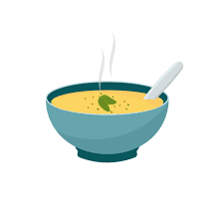  Corn Muffin Fruit Cocktail 805
9 Frozen Meal Pickup  9:30 am – 10:30 am Door #4 |   10 | 11 | 12 | 13
Tray Meal  Hearty Turkey Stew  Garlic Mashed Potatoes  Green Beans  Dinner Roll  Lorna Doones (613) | Meatballs with Sweet Chili Sauce over White Rice  Broccoli Florets    Carrots  Strawberry Gelatin  (613) | Tortellini with Diced Chicken & Red Pepper Cream Sauce    California Blend Vegetables    Grape Juice  Chef Salad with Dressing  Italian Bread  Fresh Banana (691) | Roast Pork Loin with Warm Cinnamon Apples  Sweet Potatoes  Brussels Sprouts  Dinner Roll  Oatmeal Cookies (763) | Omelet with Pepper & Onion Cheese Sauce  Rosemary-seasoned Potatoes  Mixed Vegetables  Wheat Bread  Pineapple Tidbits  Chocolate Milk (664)
16 Frozen Meal Pickup  9:30 am – 10:30 am Door #4 | 17 St. Patrick’s Day Meal | 18 | 19 | 20 Welcome Spring!
Tray Meal  Pork Ribette with BBQ Sauce on a Bun  Duchess Potatoes  Green Peas  Sugar Cookies (980) | Corned Beef with Cabbage  Buttered Potatoes    Carrots Deli Rye Bread    Lime Sherbet  (655) | Breaded Chicken Cutlet  w/ Herb Gravy Green Beans  Mashed Sweet Potatoes  Wheat Dinner Roll Butterscotch Pudding (750) | Italian Sausage with Tomato Sauce on a Bun  Corn Spinach  Tropical Fruit  Chocolate Milk (608) | Lasagna Roll with Primavera Cream Sauce Broccoli Florets    Chef Salad with Garbanzo Beans & Dressing Dinner Roll Lemon Meringue Pie (874)
23 Frozen Meal Pickup  9:30 am – 10:30 am Door #4 | 24 |   25 | 26 | 27
Tray Meal  Chicken Vegetable Casserole Mashed Potatoes  Green Beans  Dinner Roll Applesauce  (548) | Chili con Carne with Cheddar Apple Juice  Carrots  Corn Muffin  Chef Salad with Dressing  Fresh Banana (912) |   Roasted Turkey with Stuffing, Gravy & Cranberry Sauce  Mashed Butternut Squash  Cauliflower  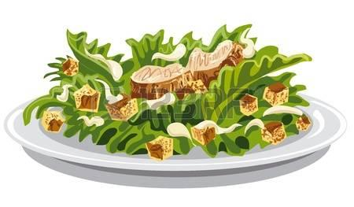  Lorna Doones (621) | Polish Sausage with Sauerkraut & Mustard on a Bun Scalloped Potatoes  Peas with Red Peppers  Fruit Cocktail  Chocolate Milk (833) | Spanish Omelet  Cheesy Diced Potatoes  Broccoli Florets  Wheat Bread  Tropical Fruit (631)
30 Frozen Meal Pickup  9:30 am – 10:30 am Door #4 | 31 | 1 Easter Luncheon | 2 |   3 No Meals Served
Tray Meal  Turkey a la King  Mashed Sweet Potatoes  Green Beans  Warm Biscuit  Chocolate Pudding (681) | Lasagna Roll with Tomato Meat Sauce & Mozzarella    Cauliflower  Peas Italian Bread  Fresh Orange  Chocolate Milk (717) | Chicken Cordon Bleu with Herb Gravy Rosemary-seasoned Potatoes  Vegetable Medley  Chef Salad with Dressing  Dinner Roll  Coconut Cream Pie (1098) | Polynesian Chicken Stew over White Rice  Carrots  Broccoli Florets    Sugar Cookies  (631) |     Senior Center Closed






