Monday | Tuesday | Wednesday | Thursday | Friday
6 Frozen Meal Pickup  9:30 am – 10:30 am Door #4  Dyngus Day | 7 | 8 | 9 | 10
Cabbage Roll with Savory Meat Sauce  Garlic Mashed Potatoes  Mixed Vegetables  Dinner Roll  Chocolate Cream Pie  (1040) | Breaded Chicken Cutlet with Buffalo-style Sauce on a Bun  Tater Tots      Seasoned Broccoli  Fudge Round  (852) | Polish Sausage with Sauerkraut & Mustard  on a Bun  Ranch Mashed Potatoes  Carrots    Fresh Apple  Chocolate Milk  (807) | Roasted Turkey with Stuffing, Gravy & Cranberry Sauce  Mashed Butternut Squash  Corn  Chef Salad with Dressing  Mandarin Oranges  (660) | Omelet with Creole Sauce  Cheesy Diced Potatoes  Green Beans    Wheat Bread  Tropical Fruit  (628)
13 Frozen Meal Pickup  9:30 am – 10:30 am Door #4 |   14 | 15 | 16 | 17
Lasagna Roll with Tomato Meat Sauce & Mozzarella  Broccoli Florets  Grape Juice  Italian Bread Sugar Cookies (796) | Swedish Meatballs over Pasta    Harvard Beets  Green Peas  Pineapple Tidbits  (659) | Chicken Breast with  Herb Gravy  Sweet Potatoes  Lima Bean Bake  Dinner Roll  Fresh Orange  Chocolate Milk (656) |   Hearty Pork Stew  Mashed Potatoes  Carrots  Chef Salad with Dressing  Dinner Roll  Strawberry Gelatin (686) | Breaded Chicken Cutlet with BBQ Sauce on a Bun    Rosemary-seasoned Potatoes  Au Gratin Spinach  Vanilla Pudding (779)
20 Frozen Meal Pickup  9:30 am – 10:30 am Door #4 | 21 | 22 | 23 Entrée Salad | 24
TRAY MEAL  Chicken Breast with Marsala Sauce  Mashed Potatoes  Mixed Vegetables  Dinner Roll Brownie  (639) | Beef Pepper Steak Casserole over White Rice      Broccoli Florets  Carrots  Sugar Cookies  (677) | Roasted Pork Loin with Warm Cinnamon Apples  Sweet Potatoes  Green Beans  Wheat Bread  Butterscotch Pudding  (644) | Garden Chicken Patty Salad with Cheddar &  Ranch Dressing  Multigrain Bread  Fresh Banana  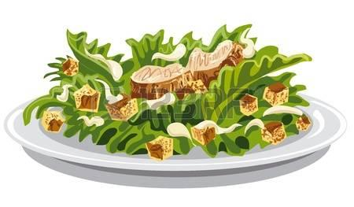  Chocolate Milk (986) | Stuffed Shells with Tomato Meat Sauce & Mozzarella  Cauliflower  Fruit Punch  Chef Salad with Dressing  Wheat Dinner Roll  Mandarin Oranges (875)
27 Frozen Meal Pickup  9:30 am – 10:30 am Door #4 | 28 Entrée Salad | 29 | 30 | 1
TRAY MEAL  turkey a la King  Mashed Potatoes  Carrots  Warm Biscuit  Chocolate Pudding  (685) | Greek Chicken Salad with Greek Dressing  Wheat Dinner Roll  Pineapple Tidbits  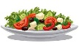  (653) | Baked Rigatoni with Italian Sausage, Tomato Sauce & Mozzarella  California Blend Vegetables  Orange Juice    Chef Salad with Dressing  Dinner Roll  Fresh Apple (779) | Baked Ham with  Pineapple Sauce  Scalloped Potatoes  Brussels Sprouts  Multigrain Bread  Lorna Doones  (678) | Beer Battered Fish  with Tartar Sauce  Broccoli Cheese Rice Casserole  Mixed Vegetables  Wheat Dinner Roll  Tropical Fruit  Chocolate Milk (704)




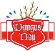

*If you have a food allergy, please notify us.

