Monday | Tuesday | Wednesday | Thursday | Friday
1 Frozen Meal Pickup  9:30 am – 10:30 am Door #4 | 2 No Meals Served | 3 | 4 Entrée Salad | 5
TRAY MEAL  Breaded Chicken Cutlet  & Gravy Scalloped Potatoes  Broccoli Florets  Wheat Bread  Fudge Round (820) |     Senior Center Event | Baked Ham with Maple Sauce  Sweet Potatoes  Lima Bean Bake  Rye Bread  Pineapple Tidbits  (619) | Chicken Caesar Salad with Caesar Dressing      Dinner Roll  Fresh Orange  Chocolate Milk  (805) | Lasagna Roll with Tomato Meat Sauce &Mozzarella  Carrots Grape Juice  Chef Salad with Dressing  Wheat Dinner Roll  Sugar Cookies (910)
8 Frozen Meal Pickup  9:30 am – 10:30 am Door #4 | 9 | 10 Tortellini & Diced Chicken | 11 | 12
REGULAR MEAL  Hearty Turkey Stew  Garlic Mashed Potatoes  Green Beans Dinner Roll  Lorna Doones  (613) | Meatballs with Sweet Chili Sauce over White Rice    Broccoli Florets    Carrots  Strawberry Gelatin  (613) | with Red Pepper Cream Sauce  California Blend Vegetables  Grape Juice  Chef Salad with Dressing  Italian Bread  Fresh Apple  Chocolate Milk (705) | Roast Beef with Horseradish & Gravy on a Bun  Mashed Potatoes  Brussels Sprouts  Oatmeal Cookies  (868) | Beer Battered Fish with Tartar Sauce  Macaroni & Cheese  Mixed Vegetables  Coleslaw  Pineapple Tidbits  (712)
15 Frozen Meal Pickup  9:30 am – 10:30 am Door #4 | 16 | 17 Father’s Day Lunch | 18 Juneteenth Lunch | 19 No Meals Served
TRAY MEAL  Hamburger with BBQ Sauce on a Bun Duchess Potatoes  Peas Sugar Cookies (887) | Italian Sausage with Peppers, Onions & Tomato Sauce  On a Bun Corn Spinach  Tropical Fruit  Chocolate Milk (608) |   Breaded Boneless Pork Chop with Stuffing & Gravy  Ranch Mashed Potatoes  Green Beans w/Red Pepper  Chef Salad with Dressing Peach Pie with Whipped Topping (1079) | Breaded Chicken Drumsticks  Sweet Potatoes  Seasoned Mixed Greens  Corn Muffin  Banana Cream Pie  (1054) | 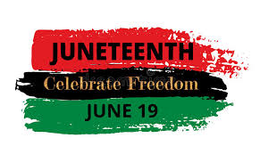  Senior Center Closed
22 Frozen Meal Pickup  9:30 am – 10:30 am Door #4 | 23 Welcome Summer! | 24 | 25 | 26
TRAY MEAL  Chicken Vegetable Casserole Mashed Potatoes  Green Beans  Dinner Roll  Applesauce (548) |   Mandarin Chicken & Sunflower Salad w/ Dressing Wheat Dinner Roll    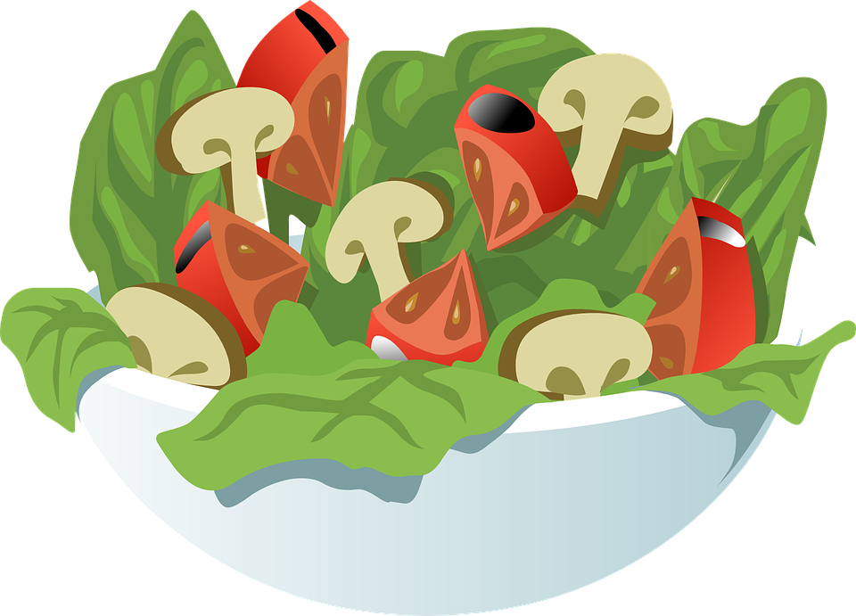    Chocolate Covered Ice Cream Bar (741) | Chili con Carne with Cheddar  Carrots  Apple Juice  Chef Salad with Dressing  Corn Muffin  Fresh Orange (869) | Polish Sausage with Sauerkraut & Mustard on a Bun  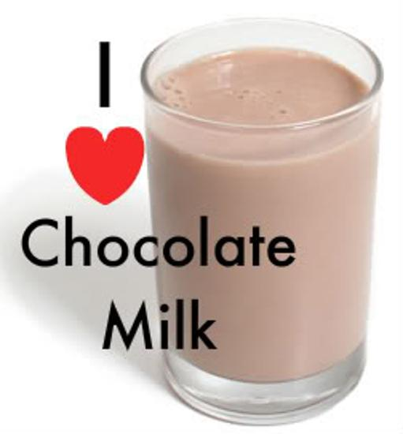  Scalloped Potatoes  Peas with Red Pepper  Fruit Cocktail  Chocolate Milk (833) | Salisbury Steak with Gravy  Garlic Mashed Potatoes  Mixed Vegetables  Wheat Bread  Sugar Cookies  (829)
29 Frozen Meal Pickup  9:30 am – 10:30 am Door #4 | 30 | 1 | 2 Independence Day Lunch | 3 No Meals Served
TRAY MEAL  Turkey a la King  Mashed Sweet Potatoes  Green Beans Biscuit  Chocolate Pudding (681) | Lasagna Roll with Tomato Meat Sauce & Mozzarella  Cauliflower  Green Peas Italian Bread  Fresh Banana  Chocolate Milk (760) | Chicken Breast with Polynesian Sauce  Rice Pilaf with Mixed Vegetables  Broccoli Florets Orange Juice  Chocolate Chip Cookies (671) |   Hot Dog with Baked Beans & Ketchup on a Bun  Macaroni Salad  Mixed Vegetables  Fruit Punch  Ice Cream Sandwich (947) |   Senior Center Closed




*If you have a food allergy, please notify us.

