Monday | Tuesday | Wednesday | Thursday | Friday
6 Frozen Meal Pickup  9:30 am – 10:30 am Door #4 | 7 | 8 | 9 | 10
TRAY MEAL  Hearty Beef Stew  Mashed Potatoes  Brussels Sprouts  Warm Biscuit  Vanilla Pudding    (703) | Breaded Chicken Patty with Buffalo Sauce on a Bun  Tater Tots  Au Gratin Broccoli    Fresh Banana  Chocolate Milk  (858) | Polish Sausage with Sauerkraut & Mustard on a Bun  Ranch Mashed Potatoes  Carrots  Fudge Round Cookie  (846) | Roasted Turkey with Stuffing, Gravy & Cranberry Sauce  Mashed Butternut Squash  Corn  Mandarin Oranges  (571) | Omelet with Cheese Sauce  Potatoes O’Brien  Green Beans  Raisin Bread      Tropical Fruit  (643)
13 Frozen Meal Pickup  9:30 am – 10:30 am Door #4 |   14 | 15 | 16 | 17
REGULAR MEAL  Lasagna Roll with Tomato Meat Sauce & Mozzarella Cheese    Broccoli Florets  Grape Juice  Italian Bread  Sugar Cookies (796) |   Swedish Meatballs over Pasta  Green Peas  Harvard Beets  Pineapple Tidbits  (659) | No Meals Served  Senior Center is Open for Activities Today | Roast Pork with Warm Cinnamon Apples    Sweet Potatoes  Green Beans  Dinner Roll  Seasonal Fruit  Chocolate Milk (620) | Beer Battered Fish with Tartar Sauce  Cheesy Broccoli & Rice  Country Mixed Vegetables  Coleslaw  Wheat Dinner Roll  Mandarin Oranges (732)
20 Frozen Meal Pickup  9:30 am – 10:30 am Door #4 | 21 | 22 | 23 Entrée Salad | 24 Christmas in July
REGULAR MEAL  Pork Ribette with BBQ Sauce on a Bun  Duchess Potatoes  Broccoli Florets  Tropical Fruit  (776) | Chicken Breast with Marsala Sauce  Garlic Mashed Potatoes  Peas with Pearl Onions    Wheat Dinner Roll  Mandarin Oranges  (579) | Hearty Pork Stew  Mashed Potatoes  Carrots  Wheat Bread  Butterscotch Pudding  (665) | Garden Chicken Patty Salad with Shredded Cheddar, Croutons & Ranch Dressing  Multigrain Bread  Fresh Banana  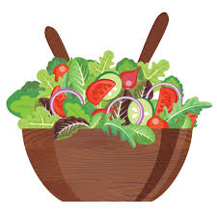  Chocolate Milk (986) | Roast Beef with Horseradish      & Gravy  Scalloped Potatoes  Brussels Sprouts  Chef Salad with Dressing  Rye Bread  Cheesecake with  Chocolate Sauce (1008)
27 Frozen Meal Pickup  9:30 am – 10:30 am Door #4  TRAY MEAL  Turkey a la King  Mashed Potatoes Carrots  Warm Biscuit  Chocolate Pudding (685) | 28 Entrée Salad  Beef Taco Salad with Cheddar Cheese, Taco Sauce & Tortilla Strips on a Bed of  Fresh Salad Greens  Pineapple Tidbits  Chocolate Milk (626) | 29  Rigatoni with Italian Sausage, Tomato Sauce & Mozzarella    California Blend Vegetables  Fruit Punch  Chef Salad with Dressing  Fresh Apple (784) | No Meals Served  Senior Center is Open for Activities Today | 31  Steakhouse Burger with Gravy on a Bun  Macaroni Salad  Lima Bean Bake  Apple Juice  Tropical Fruit  (905)




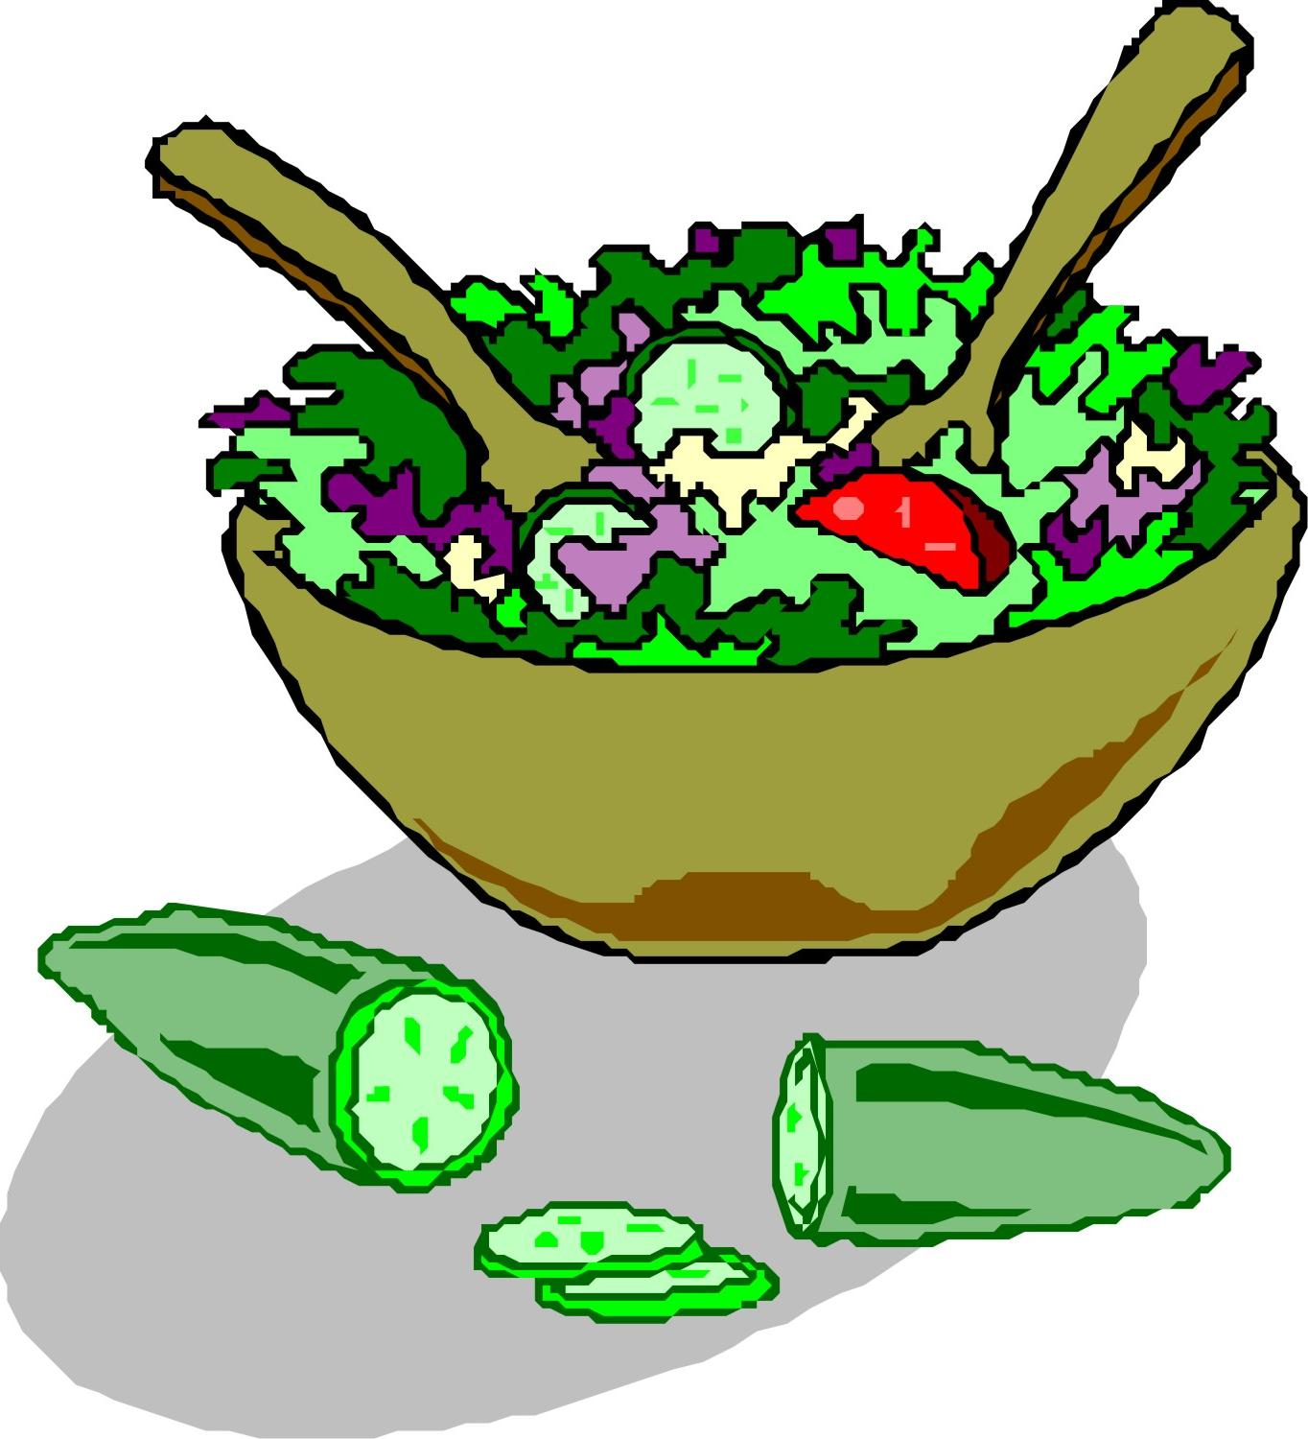


*If you have a food allergy, please notify us.
2026

