Monday | Tuesday | Wednesday | Thursday | Friday
3 Frozen Meal Pickup  9:30 am – 10:30 am Door #4  REGULAR MEAL  Beef Macaroni Casserole w/ Cheddar Cheese Green Beans Apple Italian Bread Juice Butterscotch Pudding (839) | 4  Hot Dog with Baked Beans & Ketchup on a Bun  Macaroni & Cheese  Carrots  Tropical Fruit  (746) | 5  Beef Bourguignon    Harvard Beets  Green Peas    Multigrain Bread  Fresh Orange  Chocolate Milk (647) | 6    Breaded Pork Loin with Cranberry Chutney  Mashed Potatoes  Broccoli Florets  Wheat Dinner Roll  Lorna Doones (725) | 7  Chicken Breast with Red Pepper Cream Sauce over Pasta  California Blend Vegetables  Grape Juice  Chef Salad with Dressing    Pineapple Tidbits (621)
10 Frozen Meal Pickup  9:30 am – 10:30 am Door #4 | 11 | 12 Entrée Salad | 13 | 14
TRAY MEAL  Mediterranean Chicken Casserole  Yellow Rice with Turmeric  Broccoli Florets Fruit Punch  Diced Peaches (813) | Hamburger with Onion Gravy on a Wheat Bun  Mashed Sweet Potatoes  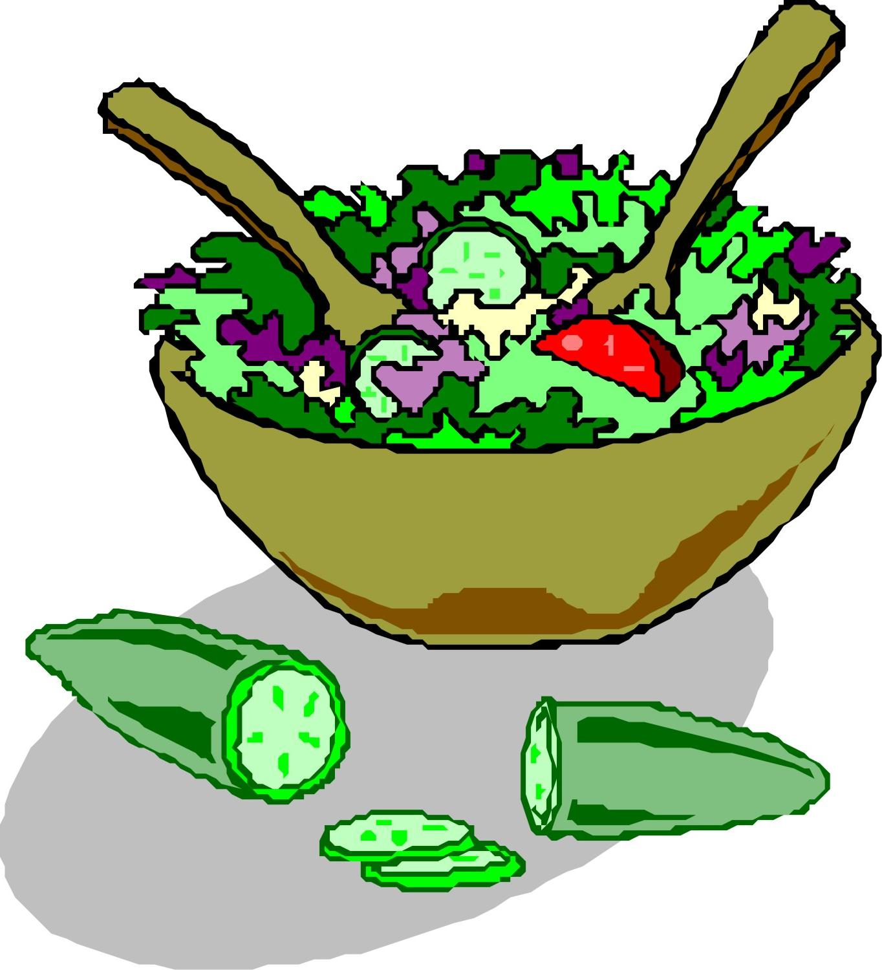    Green Beans  Vanilla Pudding (753) | Mandarin Chicken & Sunflower Salad on a Bed of Fresh Salad Greens with Dressing  Wheat Dinner Roll Banana Chocolate Milk (718) | Stuffed Shells with Tomato Meat Sauce & Mozzarella  Cauliflower Italian Bread  Orange-Pineapple Juice  Chocolate Brownie (826) |   Roasted Turkey with Stuffing & Gravy  Molded Cranberry Salad  Garlic Mashed Potatoes  Corn Diced Pears (746)
17 Frozen Meal Pickup  9:30 am – 10:30 am Door #4 | 18 | 19 | 20 | 21 Senior Citizens Day
  TRAY MEAL    Chicken Breast with Lemon Herb Sauce  Vegetable Rice Pilaf  Green Beans Dinner Roll Pineapple Tidbits (591) | Breaded Chicken Cutlet with BBQ Sauce on a Bun  Mashed Potatoes    Carrots Ice Cream Sandwich (851) | “Grown-up” Macaroni & Cheese with Diced Chicken & Breadcrumb Topping  Broccoli Florets  Zucchini & Tomatoes Wheat Bread Rice Krispie Treat (802) | Sloppy Joe on a Bun  Tater Tots  Mixed Vegetables  Mandarin Oranges  Chocolate Milk  (751) |   Broccoli-stuffed Chicken with Creamy Herb Sauce  Scalloped Potatoes  Peas with Red Peppers  Chef Salad with Dressing  Wheat Dinner Roll  Boston Crème Pie (1004)
24 Frozen Meal Pickup  9:30 am – 10:30 am Door #4 |   25 | 26 Entrée Salad |   27 | 28
TRAY MEAL    Hearty Beef Stew  Mashed Potatoes  Broccoli Florets  Warm Biscuit  Tropical Fruit (640) | Lasagna Roll with Tomato Meat Sauce & Mozzarella  Cauliflower  Grape Juice Chef Salad with Dressing Italian Bread  Oatmeal Round Cookie (864) | Greek Chicken Salad on a Bed of Fresh Salad Greens with Greek Dressing      Wheat Dinner Roll  Fresh Orange  Chocolate Milk (683) | Baked Ham with Maple Glaze  Mashed Sweet Potatoes  Peas  Rye Bread  Peach Crisp (677) | Salisbury Steak with Gravy  Scalloped Potatoes    Normandy Mixed Vegetables    Wheat Bread  Fruit Cocktail (728)
31 Frozen Meal Pickup  9:30 am – 10:30 am Door #4 | 1 |   2 | 3 | 4 Labor Day Lunch
TRAY MEAL  Cheese Omelet with Creole Sauce Potatoes O’Brien  Green Beans  Raisin Bread  Pineapple Tidbits (585) | Breaded Chicken Cutlet with Buffalo-Style Sauce on a Bun Tater Tots  Cheesy Broccoli  Chocolate Pudding(815) | Hearty Pork Stew  Mashed Potatoes  Carrots  Dinner Roll  Lorna Doones (673) | Ground Beef Taco with Cheddar Cheese & Taco Sauce on a Flour Tortilla  Spanish Rice  Fiesta Corn Tropical Fruit  Chocolate Milk (771) | Breaded Chicken Drumsticks  Ranch Mashed Potatoes  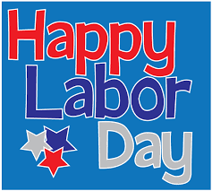  Sweet Peas  Chef Salad with Dressing  Wheat Dinner Roll  Banana Cream Pie (1119)



*If you have a food allergy, please notify us.
2026

