Monday | Tuesday | Wednesday | Thursday | Friday
  7 No Meals Served | 8 Frozen Meal Pickup  9:30 am – 10:30 am Door #4  REGULAR MEAL | 9 Meatballs with Sweet Chili | 10 Tender Pork Loin w/Gravy | 11 Beer Battered Fish w/Tartar
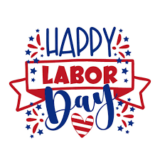  Senior Center Closed | Cheese Tortellini with Tomato Meat Sauce & Mozzarella  Mixed Vegetables Grape Juice Italian Bread Lorna Doones (774) | Sauce over Rice  Broccoli Florets Carrots Strawberry Gelatin (613) | Mashed Potatoes  Brussels Sprouts    Dinner Roll Applesauce Chocolate Milk (634) | Sauce Coleslaw  Cheesy Broccoli & Rice  Zucchini & Tomatoes Wheat Roll Pineapple Tidbits (756)
14 Frozen Meal Pickup  9:30 am – 10:30 am Door #4  REGULAR MEAL | 15 Entrée Salad |   16 |     17 | 18
Pork Ribette with BBQ Sauce on a Bun  Duchess Potatoes Carrots Tropical Fruit (766) | 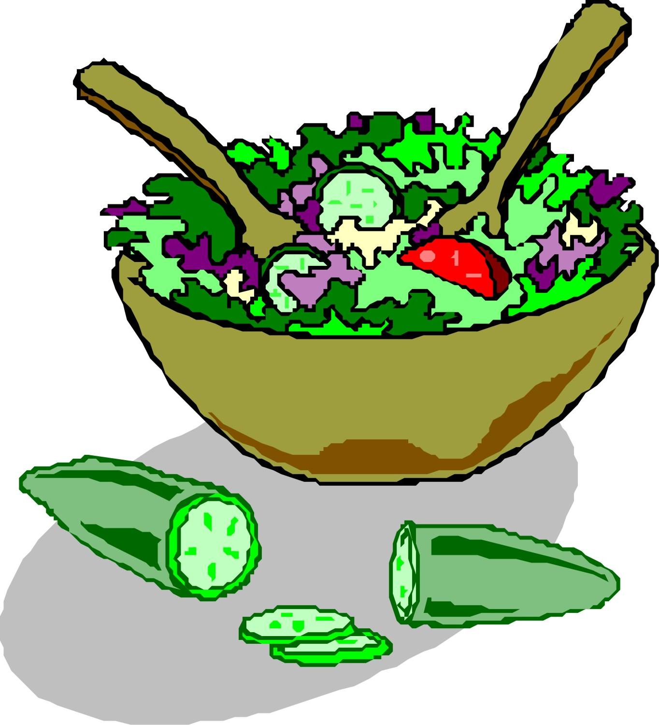    Chicken Caesar Salad- Bed of Fresh Salad Greens Wheat Roll Chocolate-covered Ice Cream Bar (871) | Italian Sausage with Peppers, Onions & Tomato Sauce on a Bun Roasted Red Potatoes    Green Beans Fresh Orange  Chocolate Milk (616) | Savory Beef Bourguignon  Mashed Potatoes  Corn Dinner Roll  Sugar Cookies (761) | Stuffed Shells with Tomato Meat Sauce & Mozzarella    Broccoli Florets Fruit Punch  Chef Salad with Dressing  Italian Bread Lemon Ice (908)
21 Frozen Meal Pickup  9:30 am – 10:30 am Door #4  REGULAR MEAL | 22 Welcome Fall | 23 | 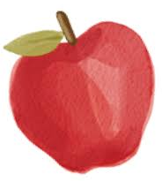  24 | 25
Chili con Carne with Cheddar Cheese Carrots  Apple Juice Corn Muffin    Pineapple Tidbits (794) | Chicken Cordon Bleu w/ Creamy Herb Sauce  Sweet Potatoes Brussels Sprouts Bread Apple Pie w/Whipped Topping(1011) | Polynesian Pork over Rice  Broccoli Florets  Fruit Punch  Applesauce (605) | Chicken Breast with Marsala Sauce Scalloped Potatoes  Mixed Vegetables  Dinner Roll Fresh Orange  Chocolate Milk (810) | Steakhouse Burger with  Onion Gravy & Bun Ranch Mashed Potatoes  Green Beans Chocolate Chip Cookies (849)
28 Frozen Meal Pickup  9:30 am – 10:30 am Door #4  REGULAR MEAL | 29 Grilled Chicken with Taco- | 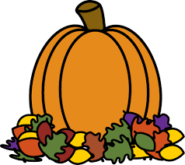  30 Soup & Salad | 1 Cabbage Roll w/y Meat | 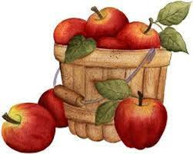  2 Hot Dog w/ Baked Beans
Lasagna Roll w/ Tomato Meat Sauce & Mozzarella Cheese  Cauliflower Sweet Peas Roll Chocolate Brownie (755) | Seasoned Peppers, Onions & Tomatoes & Cheddar Cheese  Spanish Rice  Fiesta Corn Orange Juice  Strawberry Gelatin (609) | Hearty Chicken Soup with Ditalini Noodles Peas  Chef Salad with Dressing Tropical Fruit  Chocolate Milk (634) | Sauce Garlic Mashed Potatoes Carrots Chef Salad with Dressing Italian Bread  Fresh Orange (763) | & Ketchup on a Bun  Macaroni & Cheese  Broccoli Florets  Pineapple Tidbits (749)




