Monday | Tuesday | Wednesday | Thursday | Friday
5 Frozen Meal Pickup  9:30 am – 10:30 am Door #4 | 6 | 7 Oktoberfest | 8 | 9
TRAY MEAL  Hearty Beef Stew  Mashed Potatoes  Brussels Sprouts  Warm Biscuit  Vanilla Pudding (703) | Breaded Chicken Cutlet with Buffalo-style Sauce on a Bun  Tater Tots  Peas with Red Peppers  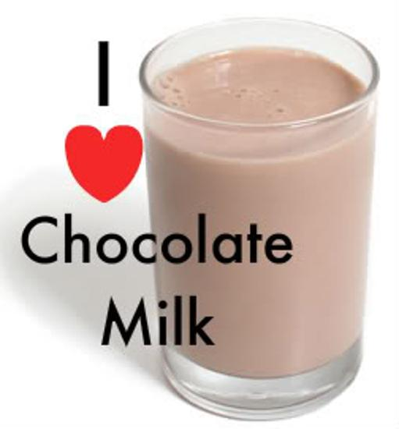    Mandarin Oranges  Chocolate Milk (805) | Polish Sausage with Sauerkraut & Mustard on a Bun  German Potato Salad    Broccoli Florets Apple Pie with Whipped Topping (966) | Roasted Turkey with Gravy  Mashed Butternut Squash  Corn  Molded Cranberry Salad    Dinner Roll  Fresh Banana  (677) | Omelet with Cheese Sauce  Potatoes O’Brien  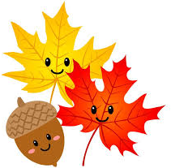  Green Beans  Raisin Bread  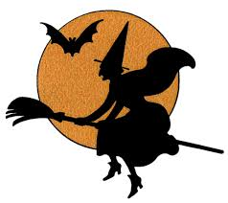  Tropical Fruit  (643)
12 Frozen Meal Pickup  9:30 am – 10:30 am Door #4 | 13 | 14 | 15 | 16
REGULAR MEAL  Lasagna Roll with Tomato Meat Sauce & Mozzarella    Broccoli Florets    Grape Juice  Italian Bread  Sugar Cookies  (796) | Breaded Chicken Cutlet with Herb Gravy  Mashed Sweet Potatoes  Corn with Red Peppers  Dinner Roll    Applesauce  (718) | Swedish Meatballs over Pasta  Tender Peas  Diced Beets  Chef Salad with Dressing    Pineapple Tidbits (717) | Hearty Pork Stew  Mashed Potatoes  Carrots  Dinner Roll    Strawberry Gelatin    (603) |   Steakhouse Burger with Gravy on a Bun  Tater Tots  Lima Bean Bake  Mandarin Oranges  Chocolate Milk  (842)
19 Frozen Meal Pickup  9:30 am – 10:30 am Door #4 | 20 | 21 | 22 Entrée Salad | 23
REGULAR MEAL  Beef Pepper Steak Casserole with White Rice  Broccoli Florets  Carrots  Lorna Doones  (655) | Chicken Breast with Marsala Sauce  Garlic Mashed Potatoes  Peas with Pearl Onions  Wheat Dinner Roll  Diced Pears  (603) | Roast Pork with Warm Cinnamon Apples  Sweet Potatoes  Green Beans  Wheat Bread  Butterscotch Pudding  (684) | 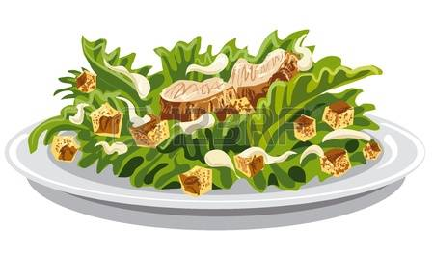  Garden Chicken Patty Salad with Cheddar Cheese & Ranch Dressing  Multigrain Bread  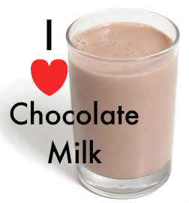  Fresh Banana  Chocolate Milk  (986) | Stuffed Shells with Tomato Meat Sauce & Mozzarella  Cauliflower  Fruit Punch  Chef Salad with Dressing  Italian Bread  Lemon Ice (904)
26 Frozen Meal Pickup  9:30 am – 10:30 am Door #4 | 27 |   28 Entrée Salad | 29 | 30 Happy Halloween
TRAY MEAL  Turkey a la King  Mashed Potatoes  Carrots  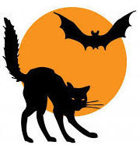  Warm Biscuit  Chocolate Pudding  (685) |   Baked Rigatoni with Italian Sausage, Tomato Sauce & Mozzarella  California Blend Vegetables  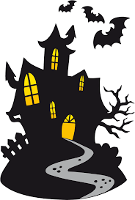  Fruit Punch  Chef Salad with Dressing  Dinner Roll  Fresh Apple (784) | Beef Taco Salad with Taco Sauce & Tortilla Strips  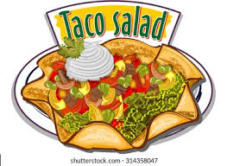  Pineapple Tidbits  Chocolate Milk (626) | Lower Sodium Baked Ham with Pineapple Sauce  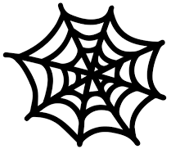  Scalloped Potatoes  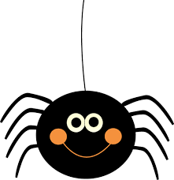  Brussels Sprouts  Wheat Dinner Roll  Chocolate Brownie  (617) | Breaded Chicken Drumsticks  Duchess Mashed Potatoes  Green Beans with Red Peppers  Dinner Roll  Banana Cream Pie  (1013)
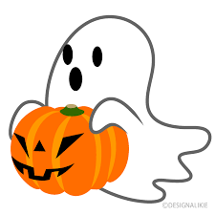


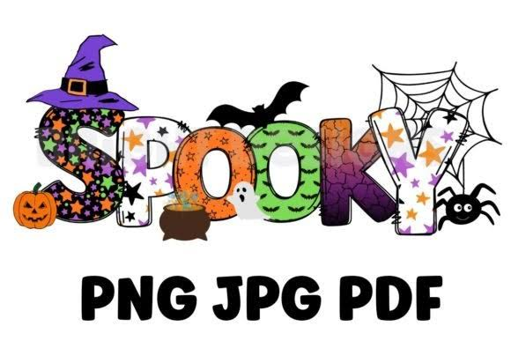

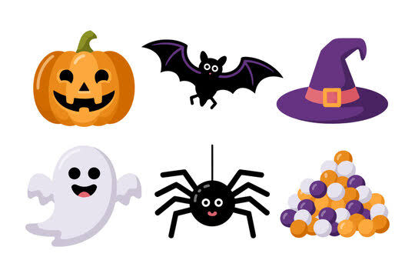

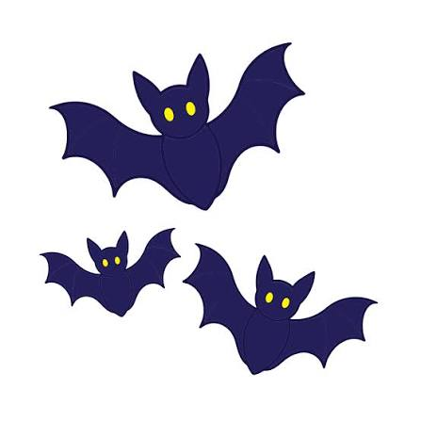

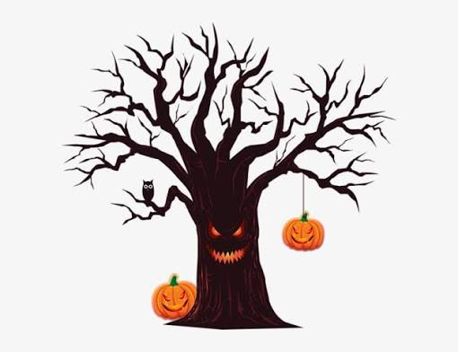
2*If you have a food allergy, please notify us.

